COLLECTIONS ASSIGNMENT

1. Given a Tree Map<Long, Contact> which has phone numbers for keys and contact objects for values.

Write solutions to

* 1. Fetch all the keys and print them,
  2. Fetch all the values and print them
  3. Print all key-value pairs

**Note:**

1. Contacts should be stored in descending order of phone number
2. Contact Class:

* PhoneNumer: <long>
* Name: <String>
* Email: <String>
* Gender: <Enum>

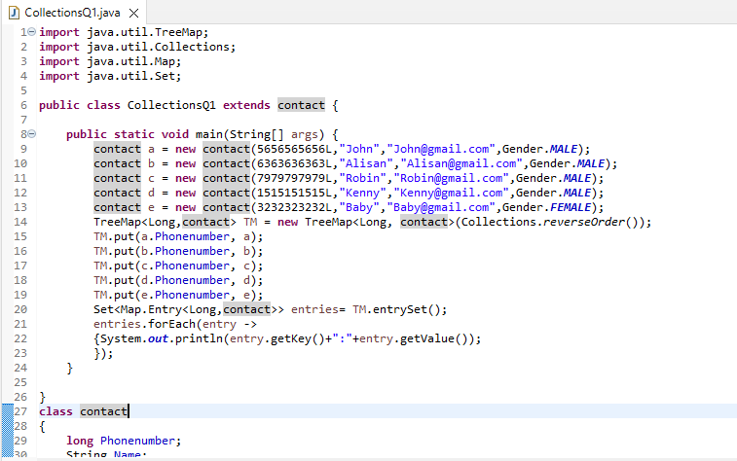

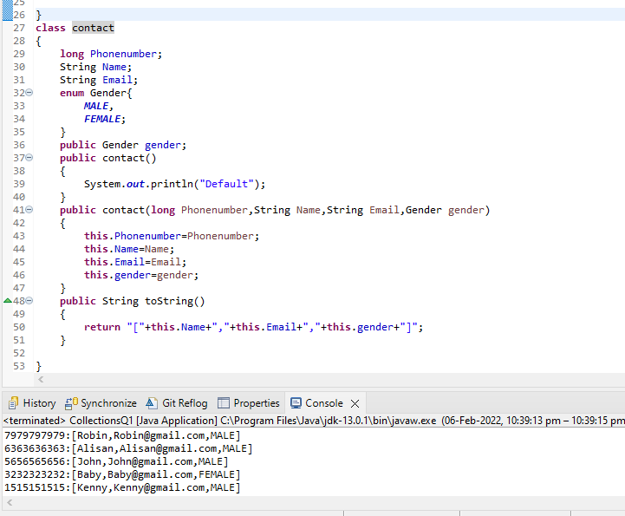

2.Write an application to store 10 unique product objects. In case there is an attempt to add a duplicate product, it should be silently rejected. Hint: **Use** HasSet or TreeSet

**Extra(optional):** Use ArrayList in the above solution. (This is optional)

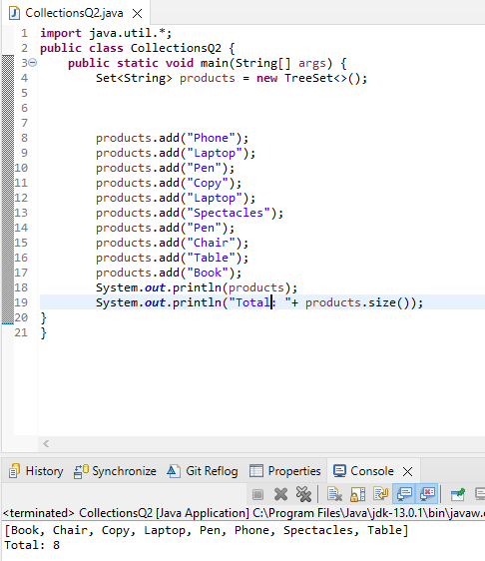

1. Store at least 10 Employee Objects in an TreeSet<Employee>. When the application runs the user should be asked to select one of the options upon which you will print the employee details in a sorted manner.

**For E.g.**

Run Application:

1. ID
2. Name
3. Department
4. Salary

Your choice: b

<Should print all the employee’s details sorted by name>

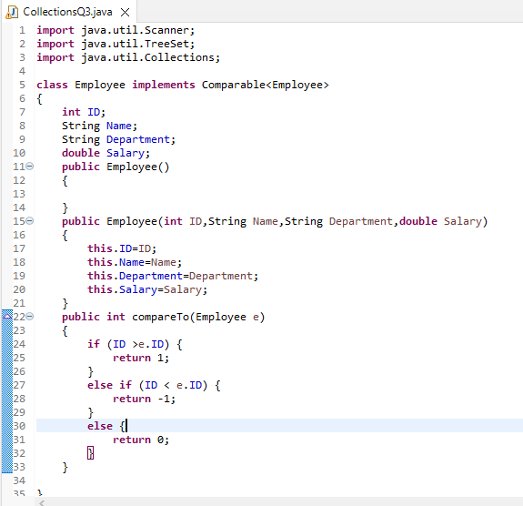

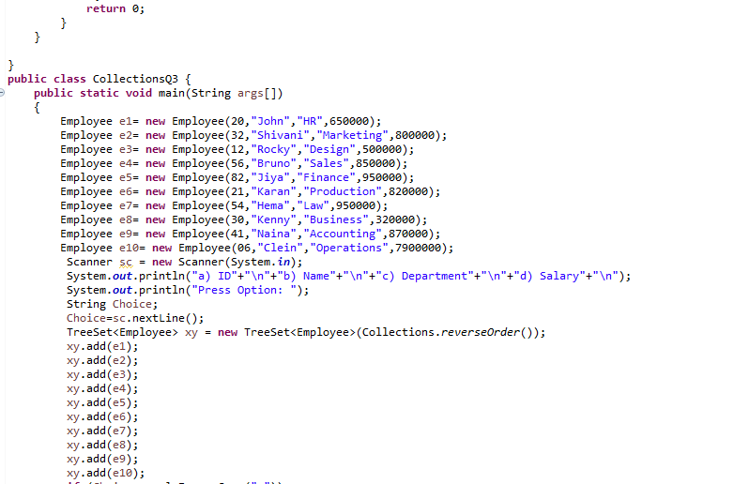

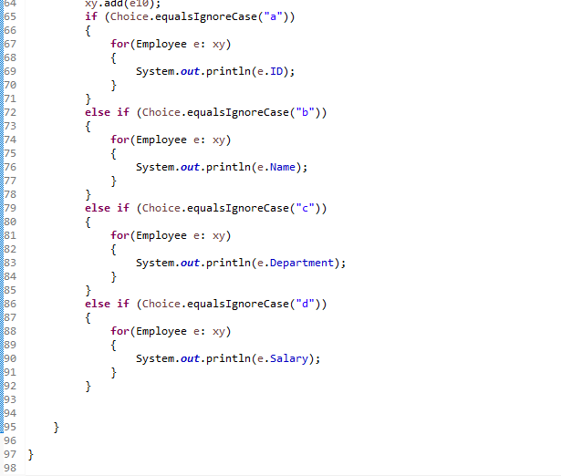

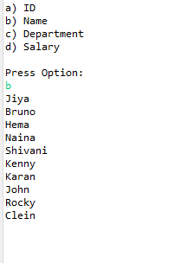

4.Given a LinkedList of Objects representing date of birth’s (use any inbuild java class to represent date), print the date’s along with the message: Your date of Birth is DD-MM-YYYY, and it (was or was not) a leap year.

E.g. a) For the date 23-12-2000

Your date of birth is 23-12-2000 and it **was** a leap year

1. For the date 23-12-2001

Your date of birth is 23-12-2000 and it **was not** a leap year

**Note**: You need to access the Dates in the reverse order. I.e. start from the last object and move towards the first object

